Purchase Wawa Shorti coupons from TEMPO and fund your student account at the same time. $5 each and $2 goes to your student account. Email Jill
cutler207@gmail.com
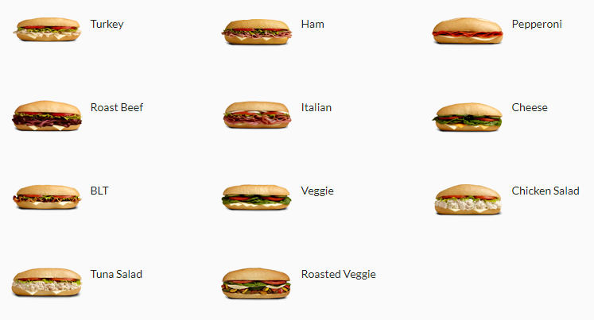
for porch pickup near ‘Stoga!

